Using GitHub Desktop
for updating the
Ethos screenshots

Table of Contents
Overview 4
Preparation 4
Localizing the screenshot macros 8
Updating Ethos screenshots 9

Overview
This document describes how to use Github Desktop to update the ethos-manual screenshots on GitHub.

There is a difference in philosophy between the way we use GitHub when doing the manuals and now when updating the screenshots.

When working on the manual we do not work in the local GitHub repository, instead we copy our screenshots from ethos-manual\<language>\assets to our local assets folder below the manual. This process is described in my “[EN] Github_how_to_rev5.pdf” document found in ethos-manual\english\docs.

To update the screenshots we have to work inside the local GitHub repository. Once updated, we revert to working on the manual outside the local repository as before.

Preparation
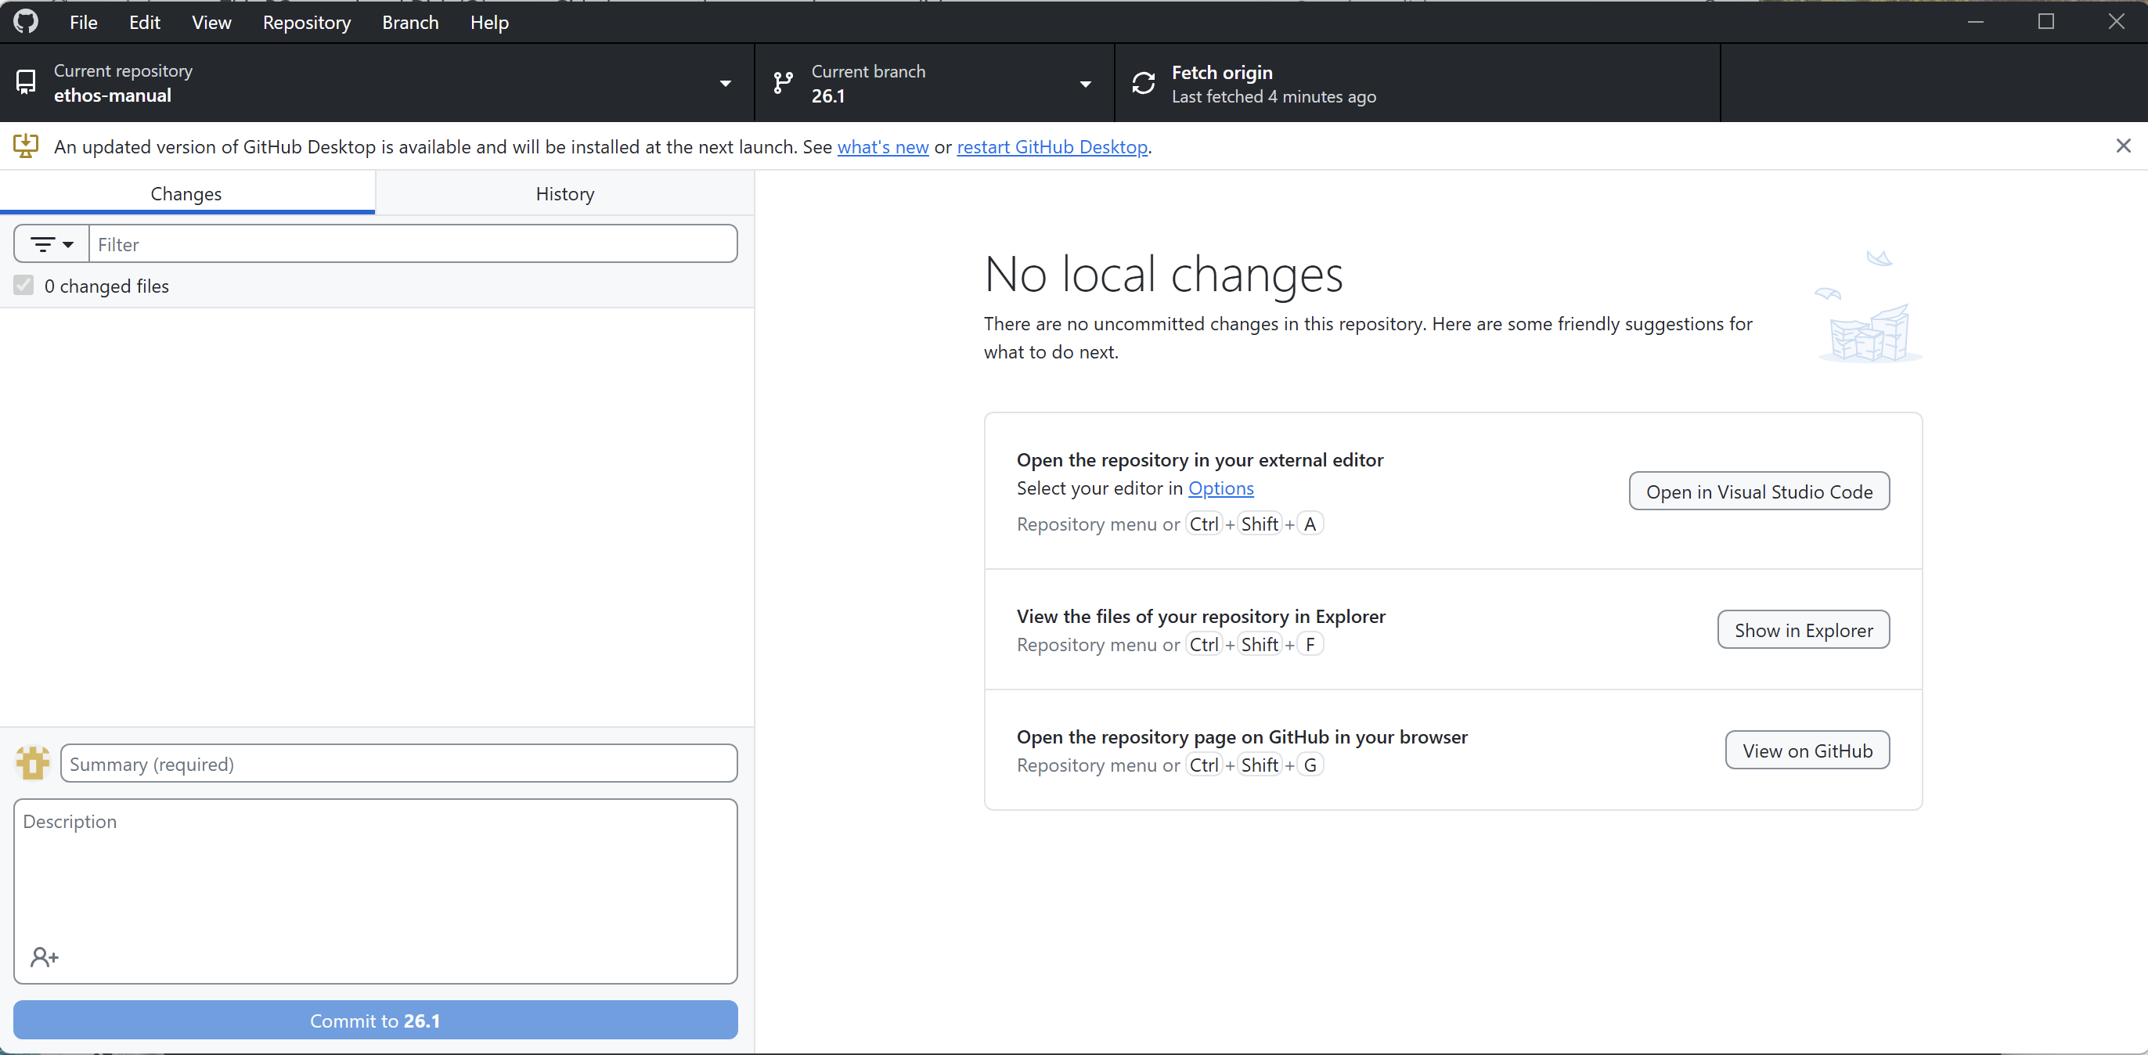

1. Do a Repository / Pull in GitHub Desktop as usual.

2. Click on ‘Show in Explorer’.

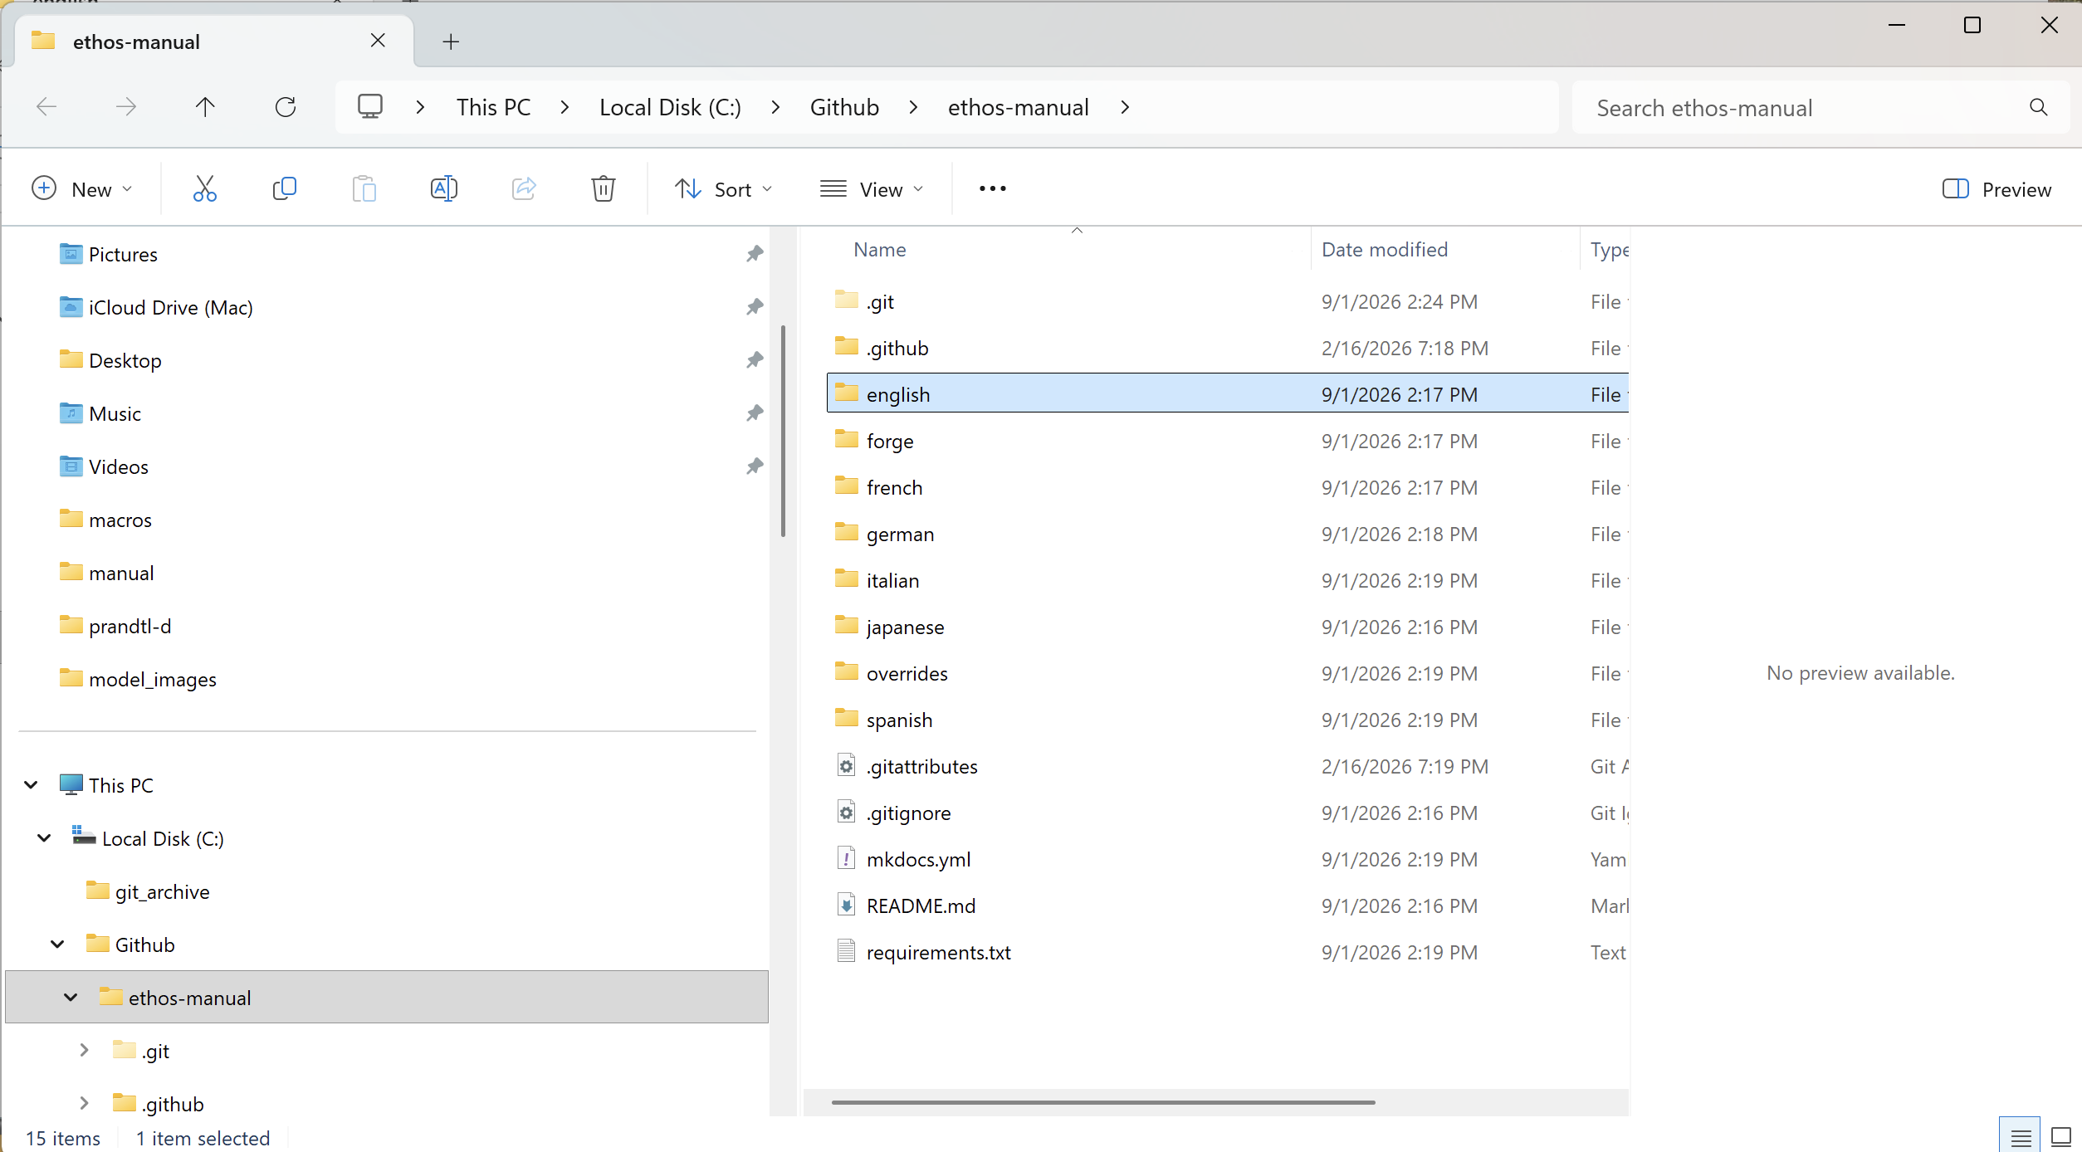

3. A Windows Explorer window will open in your local GitHub repository.

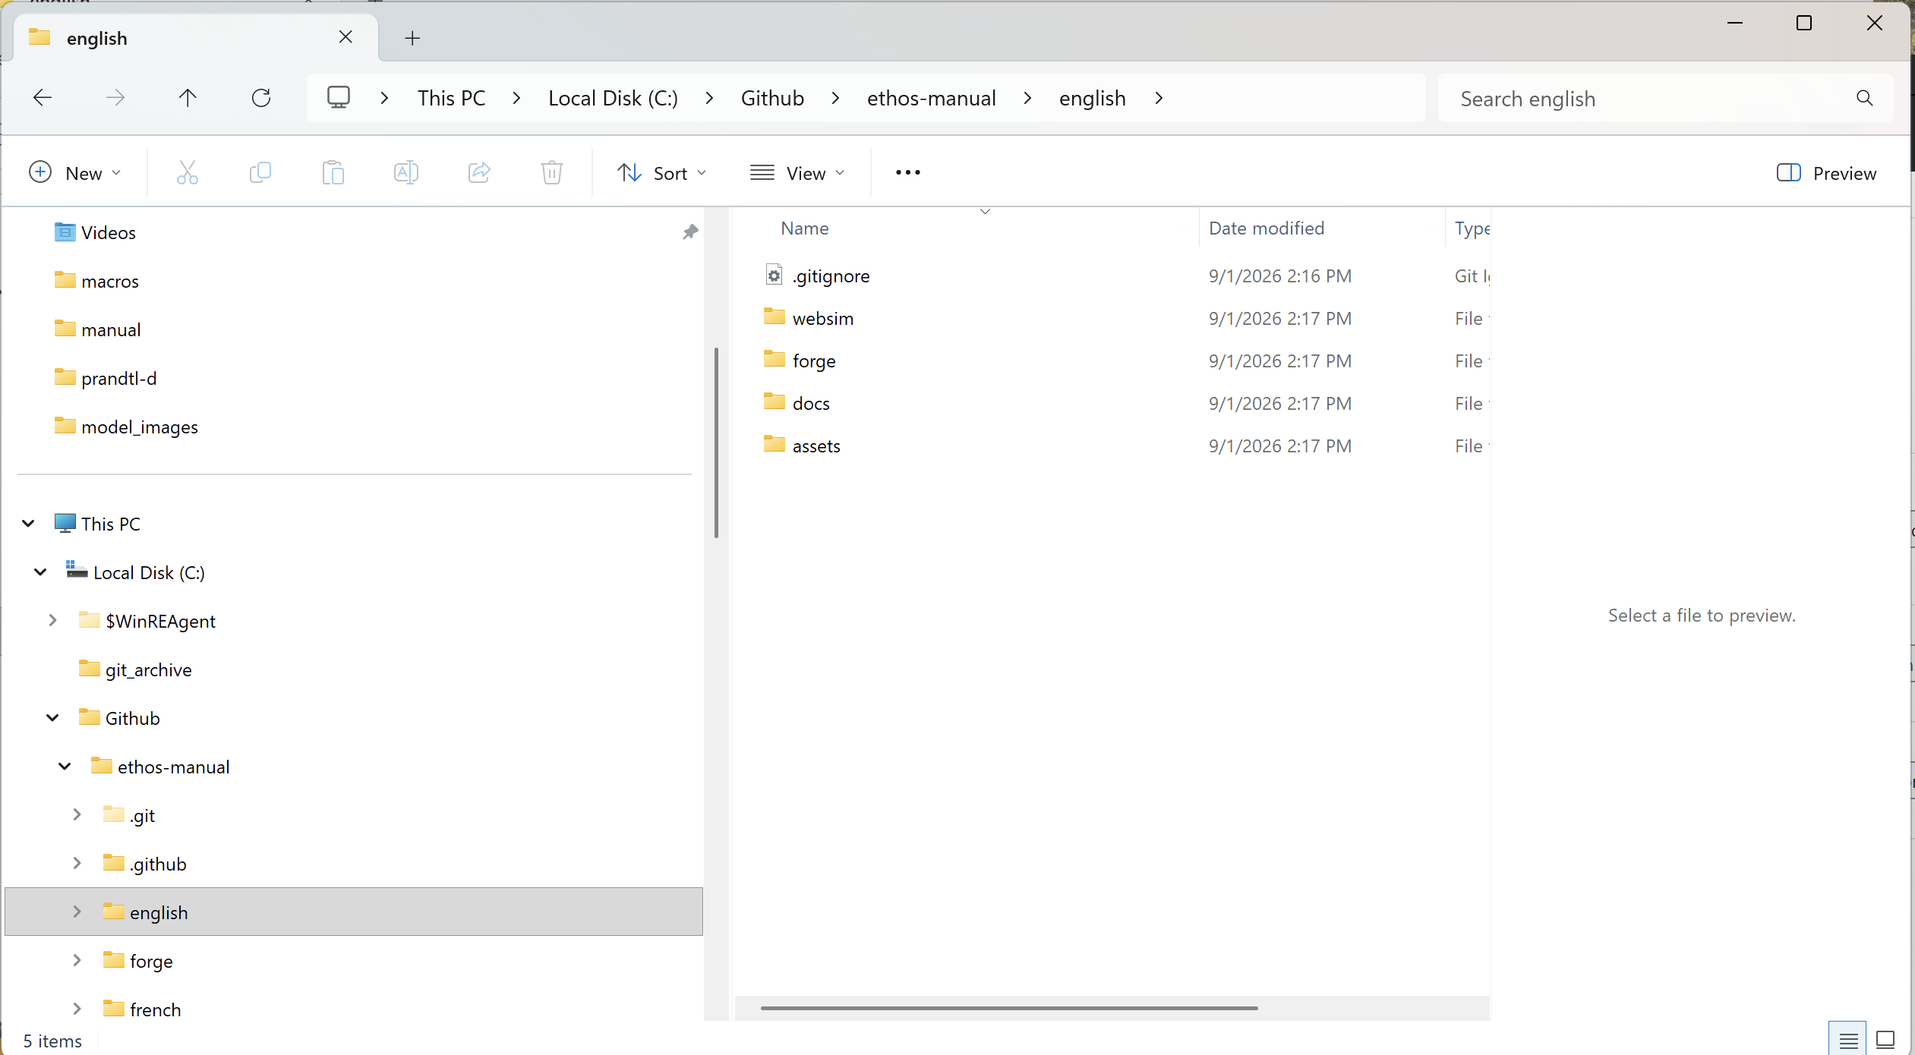

4. Open the folder for your langauge.

5. You will need to install some additional software for running the Python scripts and generating the images.

6. Right-click on an empty space in any folder and select "Open in Terminal."

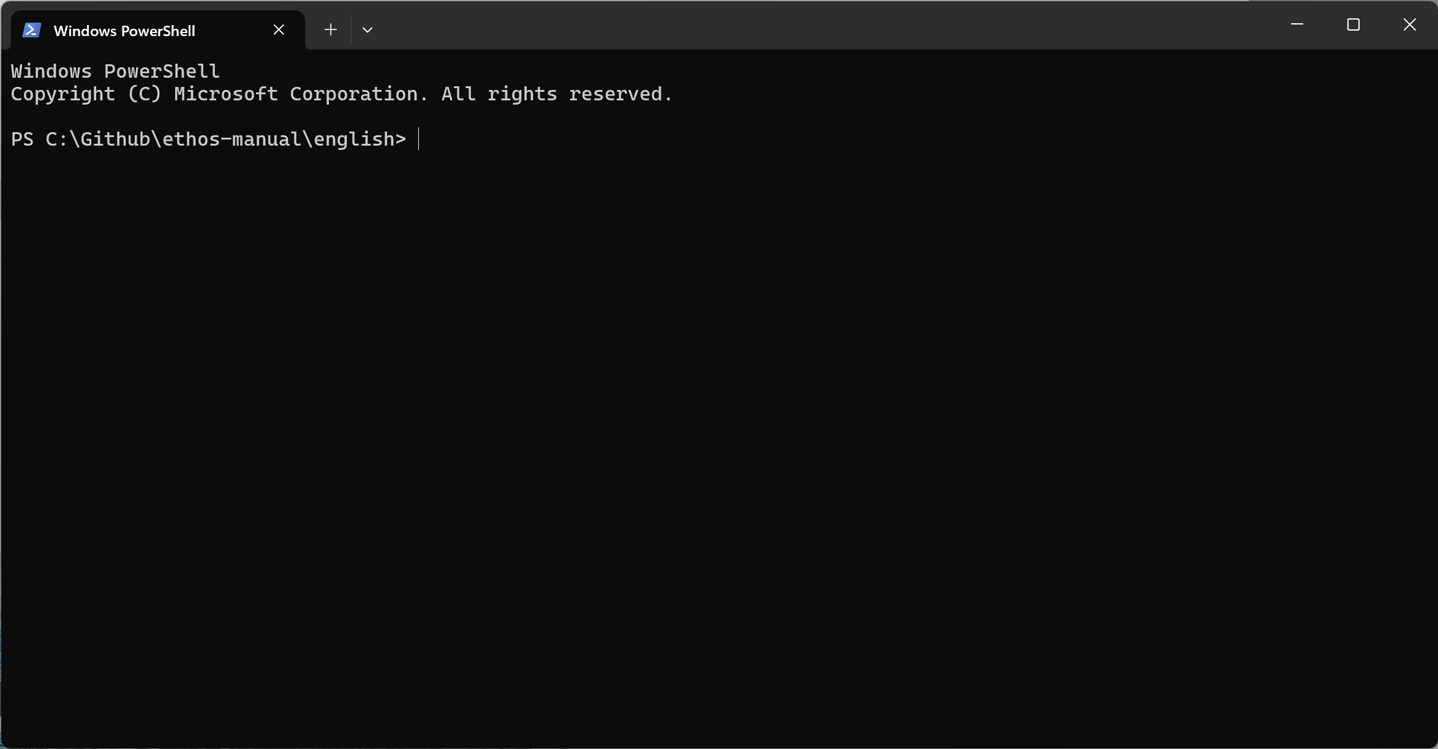

7. A Terminal window will open.

8. Type the command “Python” and Enter.

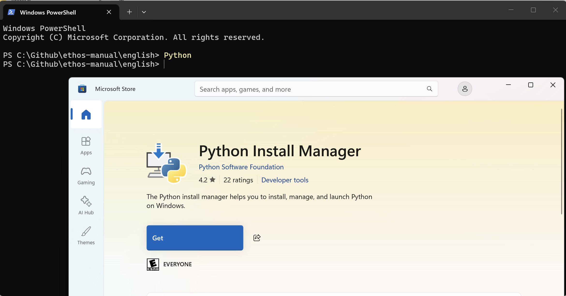

9. If Python is not installed, the MS store Python page will open so you can install it.

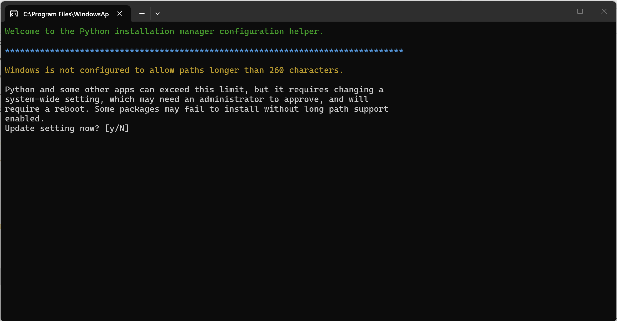

10. You may need to allow the increase of path length, configure the global shortcuts directory and download the latest Python runtime.

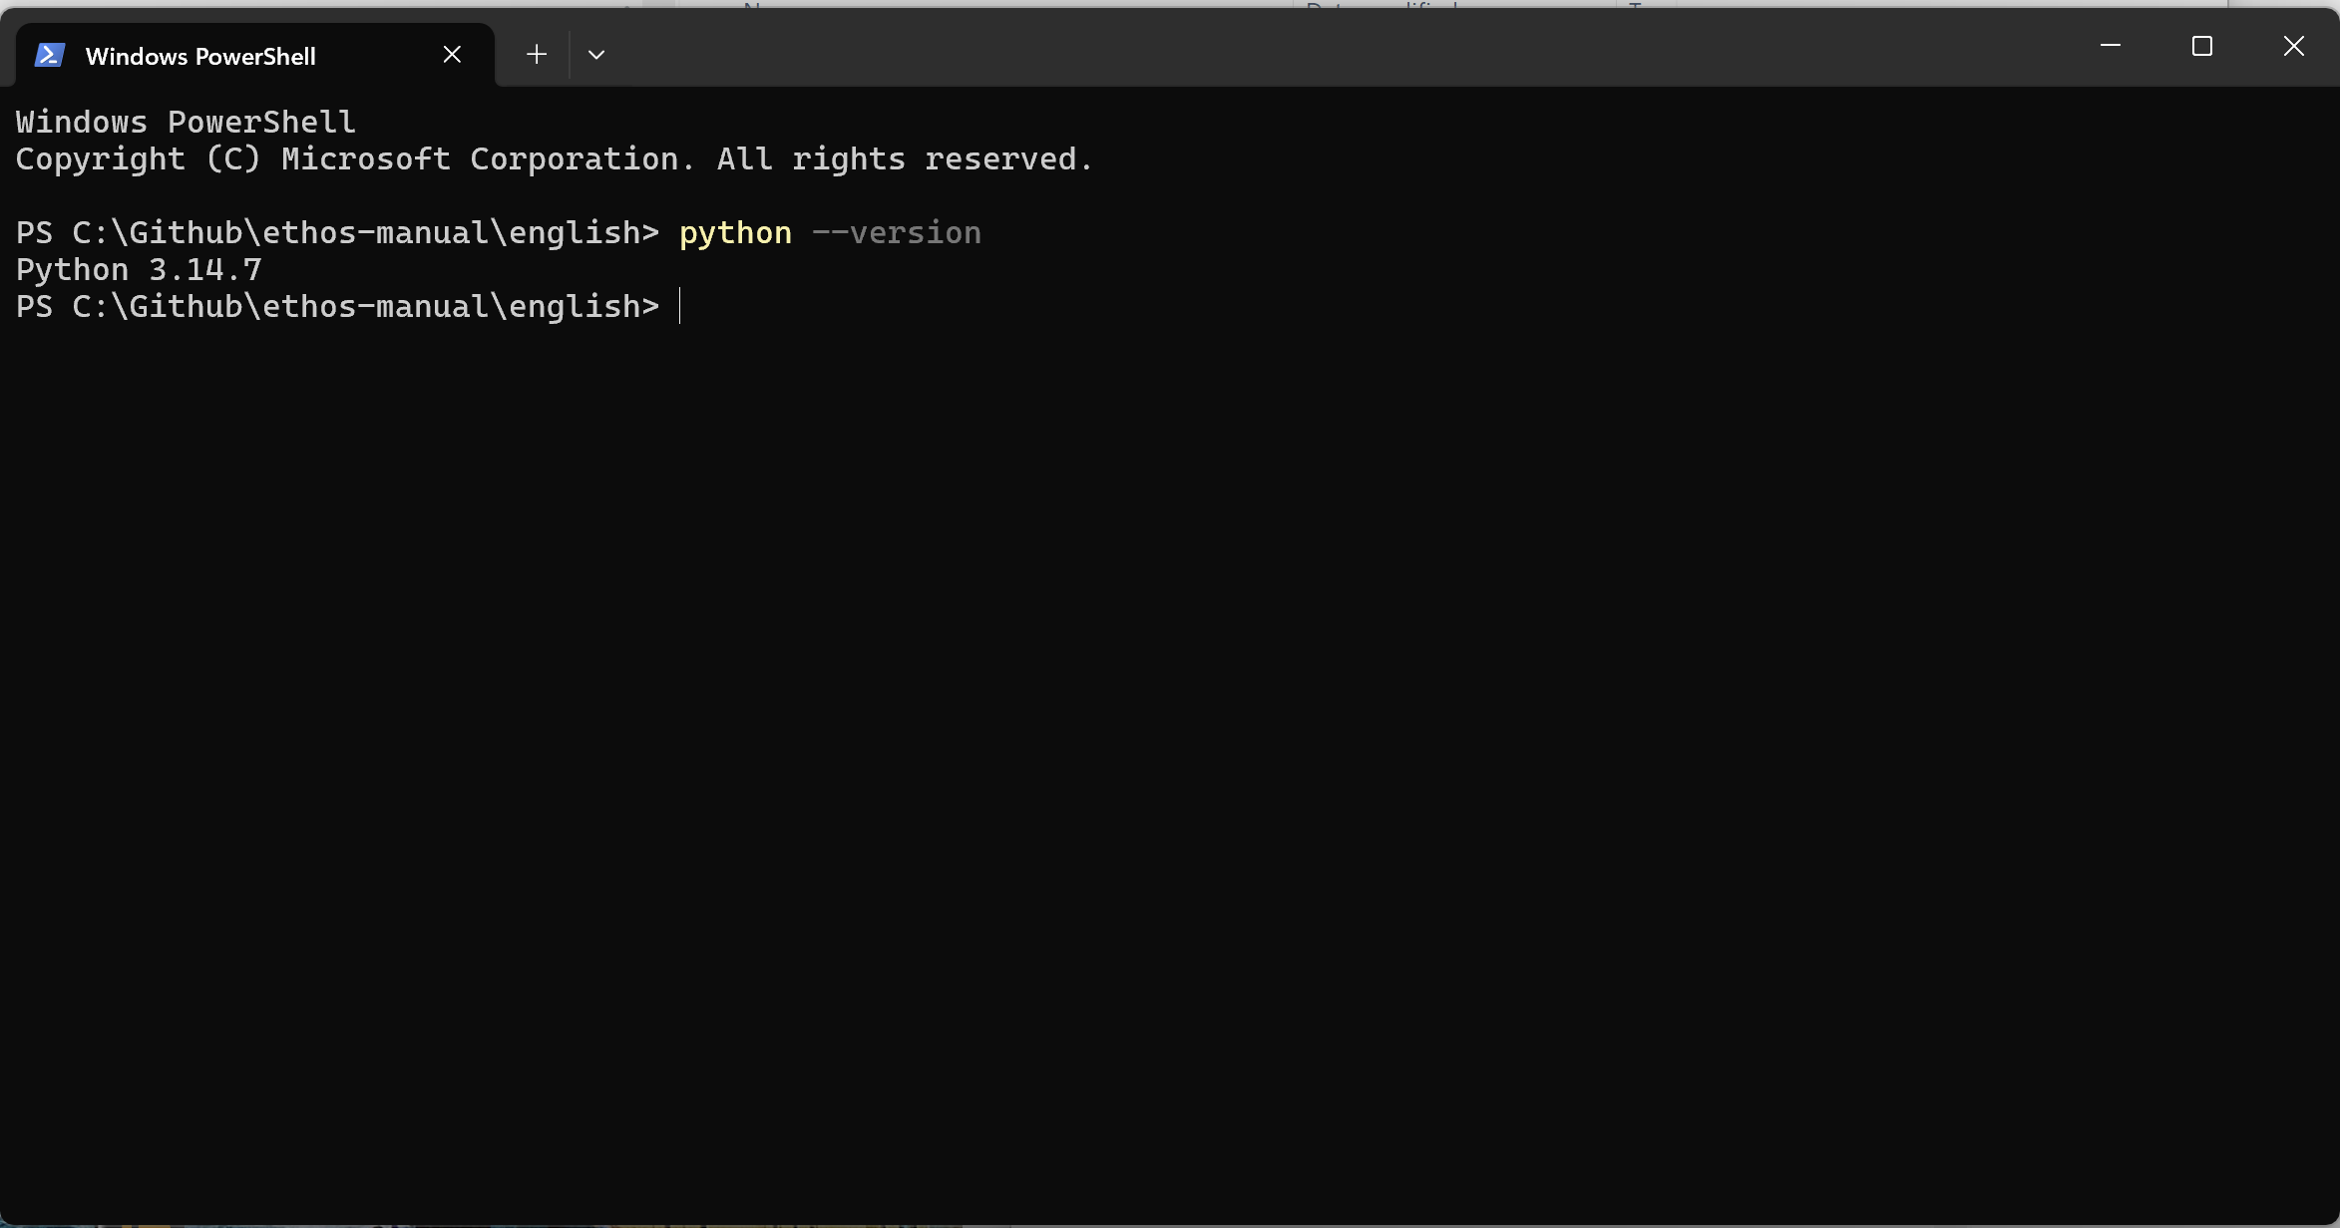

11. Finally run the command ‘python –version’ to confirm the installation.

12. Now download Node.js by going to https://nodejs.org/en/download

13. Install the downloaded Node installer. (Note I did not install the optional additional tools which take up 6Gb.)

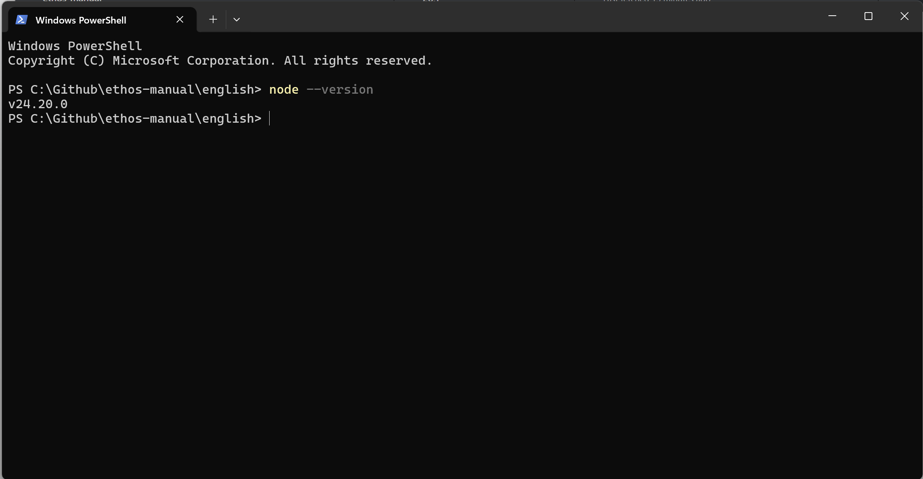

14. Repeat with the command “node –version”.

15. Now you can use python to install Pillow for Python (this is used for images generation). In the Terminal enter
`python -m pip install pillow`

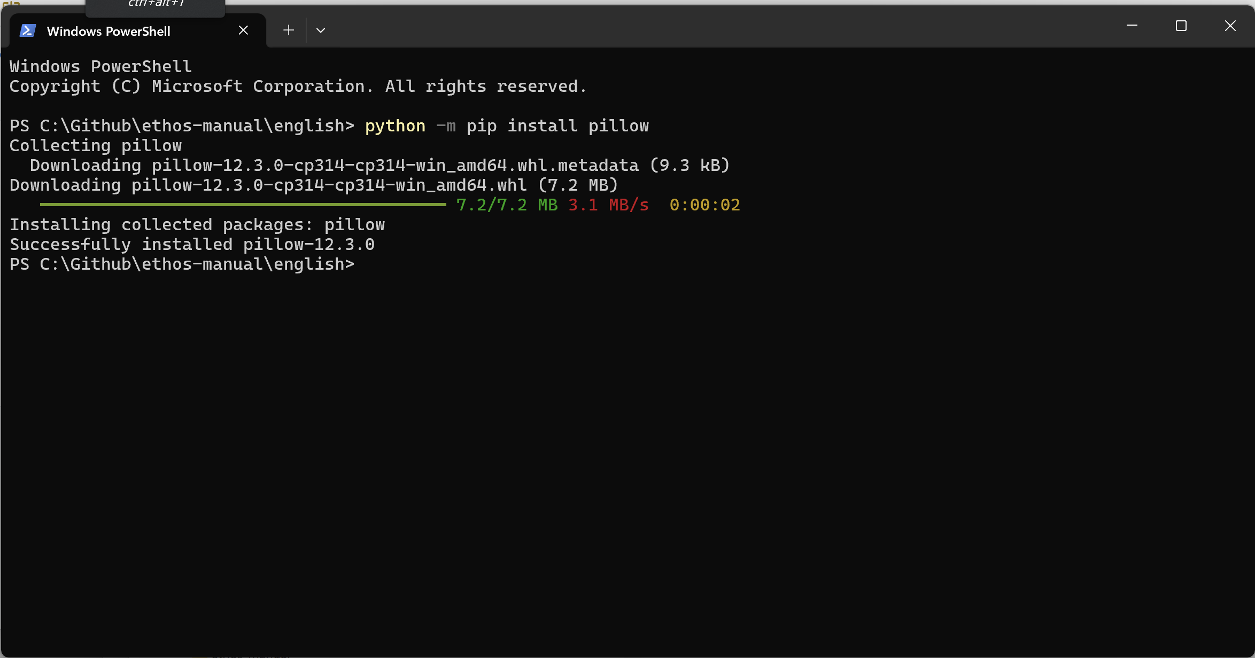

16. Pillow has been installed successfully.

17. You are now ready to update screenshots.

Localizing the screenshot macros
Before updating your screenshots, you should check that the ‘translations.lua’ file in your
C:\Github\ethos-manual\<language>\forge\macros folder is up to date.

Updating Ethos screenshots

1. Do a Repository / Pull in GitHub Desktop as usual.

2. Click on ‘Show in Explorer’.

3. A Windows Explorer window will open in your local GitHub repository.

4. Open the folder for your langauge.

5. Right-click on an empty space in any folder and select "Open in Terminal."

6. A Terminal window will open.

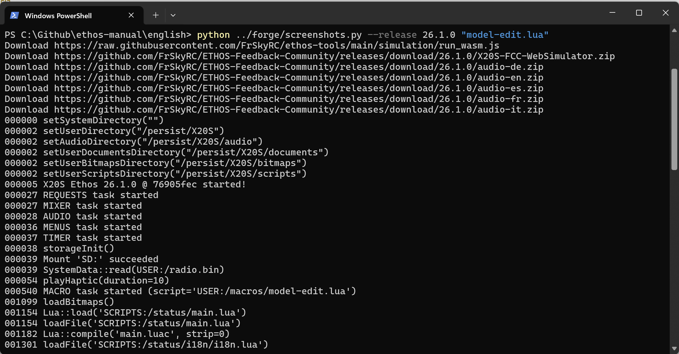

7. To test the process, run a short macro like ‘model-edit.lua’ by entering the command:
.
python ../forge/screenshots.py --release 26.1.1 “model-edit.lua”

Other options are:
python ../forge/screenshots.py --release 26.1.1 – would run all 670+ screenshots

I will give you more options e.g. for the other radios once tested.

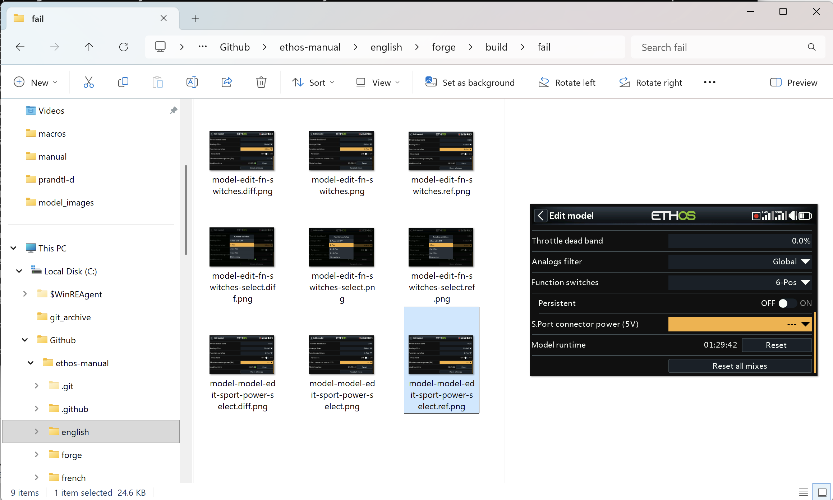

8. The `screenshots.py` script generates a `build` folder in your local ‘forge’ folder, with a subfolder called `screenshots`. In addition you will find a subfolder named `fail`.

C:\Github\ethos-manual\english\forge\build\fail

9. Once the script has completed, switch to Windows Explorer and navigate to the ‘fail’ folder.

For each screenshot which is different from the reference, you will have (for example):

model-edit-fn-switches.diff.png (this is a diff image showing differences in green)
model-edit-fn-switches.png (this is the new image)
model-edit-fn-switches.ref.png (this is the current reference image in the repo assets)

10. If there are errors or significant differences, let me know so that we can discuss them.

Up until this point, everything has been done in the ‘forge’ folders which are ignored by GitHub.

11. Once you are happy with the new screenshots, switch back to the Terminal window.

12. Ensure that you are in your <language> folder.

13. Type the command

python ../forge/accept.py

14. This this will copy the new screenshots to your assets folder.

15. Now load GitHub Desktop, it should show the new screenshots under the 'Changes' tab.

16. First do a Repository Pull.

17. Then enter a suitable Commit message, followed by a Push.

18. Please do not run the full set until I have finished migrating the macros to the forge.

